**package** Tuesday;

**import** java.util.Scanner;

**public** **class** ShortestPalindromeDemo {

**public** **static** String shortestPalindrome(String str) {

**int** x=0;

**int** y=str.length()-1;

**while**(y>=0){

**if**(str.charAt(x)==str.charAt(y)){

x++;

}

y--;

}

**if**(x==str.length())

**return** str;

String suffix = str.substring(x);

String prefix = **new** StringBuilder(suffix).reverse().toString();

String mid = *shortestPalindrome*(str.substring(0, x));

**return** prefix+mid+suffix;

}

**public** **static** **void** main(String[] args) {

Scanner in = **new** Scanner(System.***in***);

System.***out***.println("Enter a String to find out shortest palindrome");

String str=in.nextLine();

System.***out***.println("Shortest palindrome of "+str+" is "+*shortestPalindrome*(str));

}

}

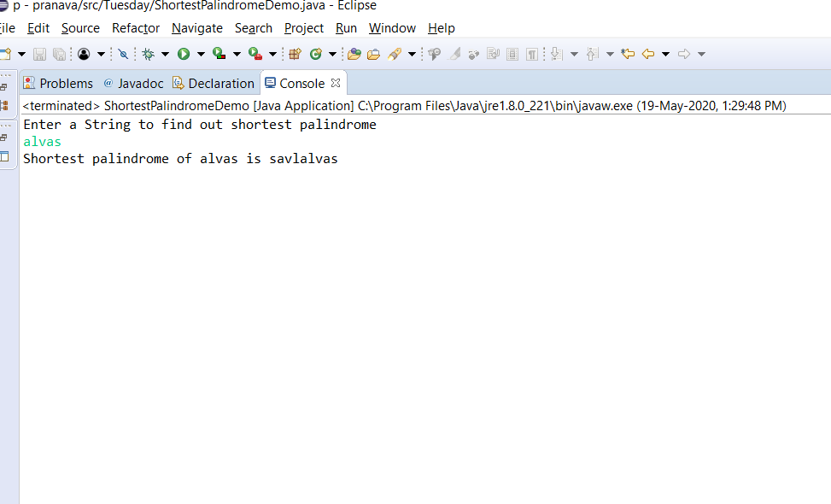

OUTPUT